Feature Image: "Gift the Perfect Men's Diamond Necklace—Shop Now!"

Title: How to Choose a Diamond Necklace for Men as a Gift
Focus Keyword: Diamond Necklace for Men
Secondary Keyword:
Diamond gold necklace mens
black diamond necklace for men

Word Count: 1000

Internal links:
mens diamond necklace: https://crystaljewelersnc.com/product-category/mens-necklace/
luxury diamond rings: https://crystaljewelersnc.com/rings/

Meta Description:
Learn how to select the ideal diamond necklace for men as a meaningful gift. Tips on styles, materials, diamond quality, and budget considerations.

How to Choose a Diamond Necklace for Men as a Gift
A diamond necklace gift for men represents something greater than a simple accessory. It is a perfect symbol that demonstrates your feelings of affection and gratitude. When selecting an emblem to express your feelings or affection, it becomes essential to emphasize all the important emotions you seek to share with someone.
It is sometimes challenging to decide on which necklace to buy for your partner, brother, father, or best friend. But do not despair, because, in this blog, we will shed some light on the whole process of selecting a perfect men’s diamond necklace as a gift..

Understand the Significance of a Diamond Necklace for Men:
First of all, it is necessary to explain the reason why a diamond necklace for men should look rather unique as a gift. A diamond, which is well known for its cut and clarity, is associated with love. That is why it is often used as a symbol of love which cannot easily be broken. It is a way of conveying confidence and class, which makes it perfect to imagine for any event that you may be planning to attend.

In addition, a diamond gold necklace mens is not only gives out the appearance of luxury but also brings out the masculinity of a man. This is due to the shine of diamonds and the potency of gold, which makes each piece classy and sturdy. This doubling, in a sense, guarantees that the necklace fits fairly any outfit from the casual to the official.

Select the Right Type of Necklace:
To pick the ideal necklace you should analyze certain key details before you buy. First, think about the occasion. Is it a birthday, anniversary or simply a bonus for you or your colleague or both of them? There are general rules and then there are tips concerning the nature of the event that you are attending.

Classic and Versatile Options:
In general, you must choose a traditional and minimalist style for a day-to-day look. In case of casual or formal wear, you can choose a single diamond pendant or luxury diamond rings set. Alternatively, there are black diamonds for men who do not aim at getting a traditional look for the noble metal.

Statement Pieces:
If you would like to make an even stronger visual impression, it is better to choose a large pendant or a more detailed design. It is suited for celebrations and it is very conspicuous and noticeable.

Occasion-Specific Choices:
In particular, when celebrating a birthday or an anniversary, it is recommended to opt for a unique design and style. Additional inscription or inclusion of birthstone adds personality to it and makes it extraordinary, unique and adorable.

Material Matters:
First of all, the choice of the material is a critical factor when it comes to choosing luxury diamond rings. Gold has been preferred by most people because it is universally accepted and also dinner out the beauty of diamonds.

Consider Gold Types:

Yellow Gold:
Most renowned and trendier, this style is most popular among the bands. It is versatile for all diamond cuts. Moreover, it is ideal for casual, formal or any occasion.

White Gold:
As far as a flashy and trendy design is a concern then white gold is the best. It complements the diamond look of the product and is frequently plated with rhodium to look more attractive.

Rose Gold:
This metal has a beautiful pinkish-gold color which gives it an unique and warm appearance to customers who wish to be different. It goes well with black diamonds, as it adds a glamorous look to it.

Learn More About Diamond Quality:
You must examine the 4C's when you are going to choose your diamond including cut quality, internal purity, weight and appearance.

Cuts:
The element of cut holds top importance for producing ideal diamond brilliance.. Find out the type of cut that would reflect the diamond ore effectively when light falls on it.

Clarity:
Diamond is not necessary to be totally refined, but make sure any obscurity can not be observed with the naked eye in the diamond.

Carat:
This is a term used to denote the weight of the diamond. Ensure that you select the diamond size chosen in relation to the preference of the wearer concerning size and cost.

Colour:
It is a tradition for men’s diamonds to be nearly colorless. Nevertheless, colored diamonds, such as the black ones, have a tendency to be distinctive.

Take Budget Into Consideration:
The cost of the jewelry that incorporates diamond can also be greatly influenced by the type of diamond used. Well, before anything else, it is very important to determine the amount of money individuals are willing to spend before shopping. More so, the cost of the diamond necklace is not just the price of the trinket but rather in the thought that is behind the gift.

- Availability: Despite the current trends and styles, it is possible to locate inexpensive items, especially when using less carat or less common metals like silver.
- Luxury Parts: Before choosing a diamond necklace to be worn by any person, consider factors like personality and above all, choose the best quality.

Where to Buy Your Favorite Diamond Necklace for Men?
You should verify that you get your diamond necklace from a trustworthy store before buying it for your male recipient. Look for jewelers who show proof of their jewelry items coming directly from the reliable manufacturer. Crystal Jewelers gained its reputation due to the regular usage of the conflict-free diamonds which are not involved in any unlawful activities.

Gifting Tips:
Last but not least, the manner of giving matters a lot; the following are some tips touching on how one can present a gift properly:
- Pleasing packaging makes your gift more unique
- A card can convey your feelings
- Timing is also critical so choose a time when the recipient has the opportunity to see and fully enjoy it.

Final Thoughts:
Purchasing a diamond necklace for men as a man’s gift is a valuable and thoughtful process. If well advised as provided by the services of Crystal Jewelers, then a good ring, pendant or any other jewelry piece can be found and purchased that will show the appreciation you hold for your loved one.
Before picking the right mens diamond necklace or black diamond necklace for men or any other design, just make sure that the most important thing that attaches to it is love. Therefore, offer a men's diamond necklace as a gift to your special someone to make them cheer and make each day special.
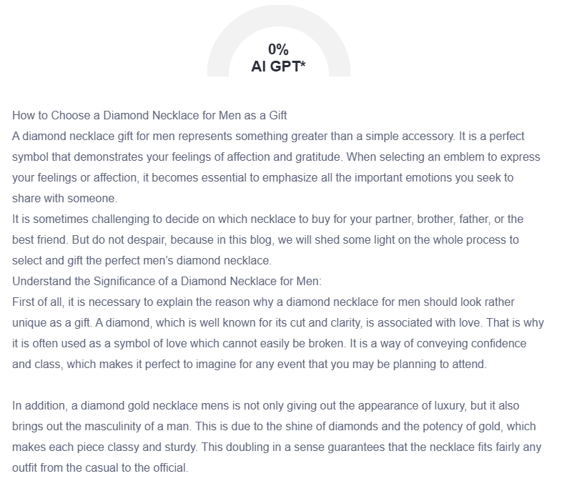

GMB

Crystal Jewelers provides customers with a selection of ideal diamond necklace gifts for their special male recipients. People use diamond necklaces to convey their sincere affection and appreciation toward others in addition to their design function. Our collection features different designs suitable for any event. Our collection includes both single diamond pendants and luxurious diamond rings, which anyone can wear on a daily basis. The collection includes bold pendants made with large glass designs for dramatic statement pieces. Our collection contains yellow gold as an all-purpose choice, along with white gold to achieve an eye-catching effect and rose gold for its one-of-a-kind warm appearance, which matches black diamonds perfectly. Our experts teach you how to select the right diamond quality according to the 4C standards. Moreover, our team guides clients to find optimal diamond quality while staying within their budget range, consistently providing creative choices. Our jewelry store upholds ethical diamond sourcing rules by exclusively sourcing conflict-free diamonds for all our jewelry designs. You will receive expert guidance at Crystal Jewelers for picking necklaces that fit your gift recipient's personal style. Visit Crystal Jewelers for a necklace that conveys confidence, class, and heartfelt emotions. We transform your thoughtful gesture into a lasting treasure that will make each day special for your loved one.

